How to Create App Services in Azure Portal{Step by Step Guide} | CyberITHub (step by step images)

Webapp creations: -Deployment configuration: -
Service connection Creation: _
- Go to azure Devops -> select project ->select service connection ->create new service connection ->select azure resource manager and click Next.

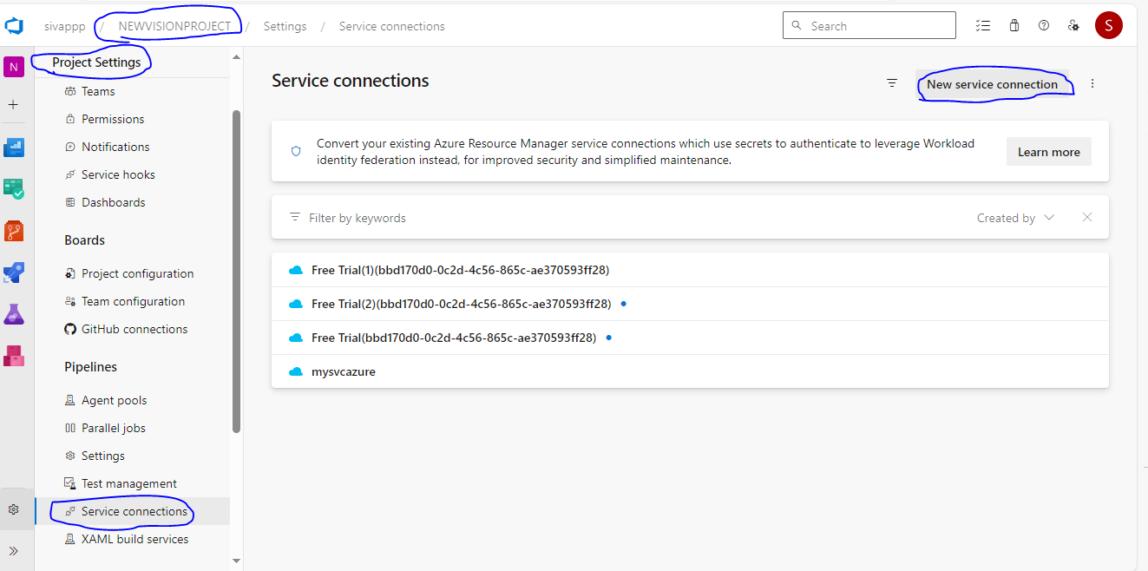
2.
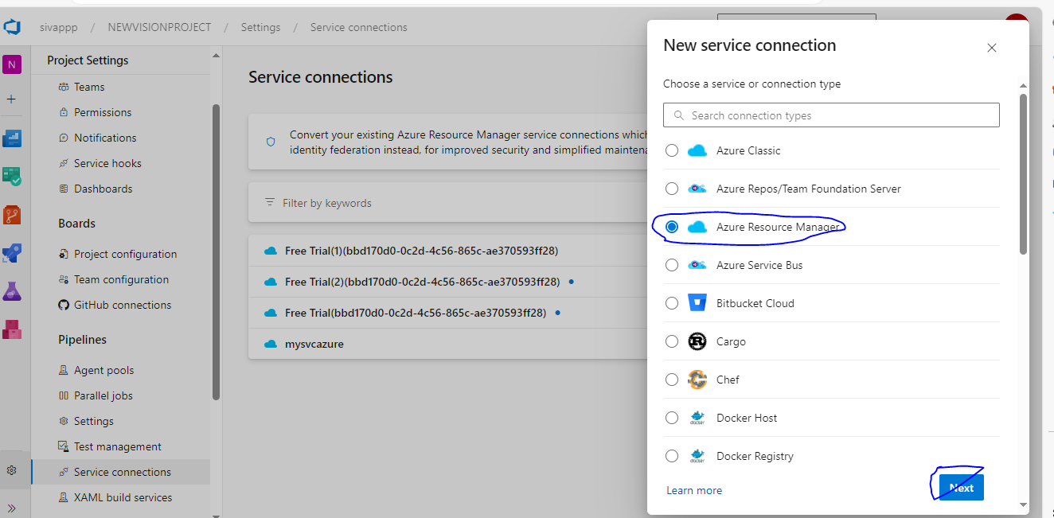

Select service principle automatic. (need select 3rd option)
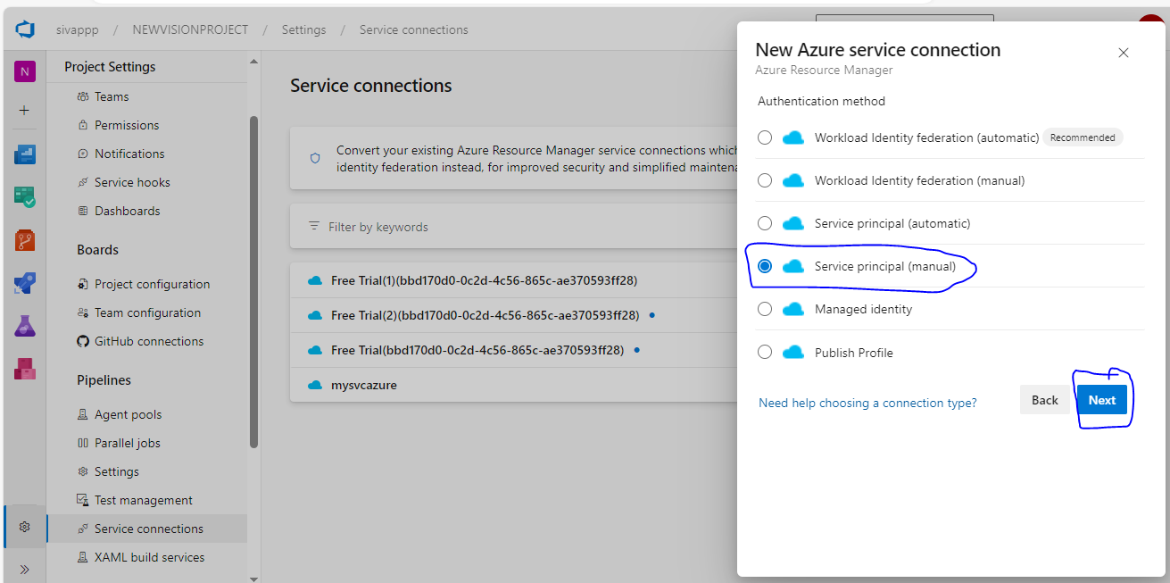

Below screenshot for service connection details for webapp.
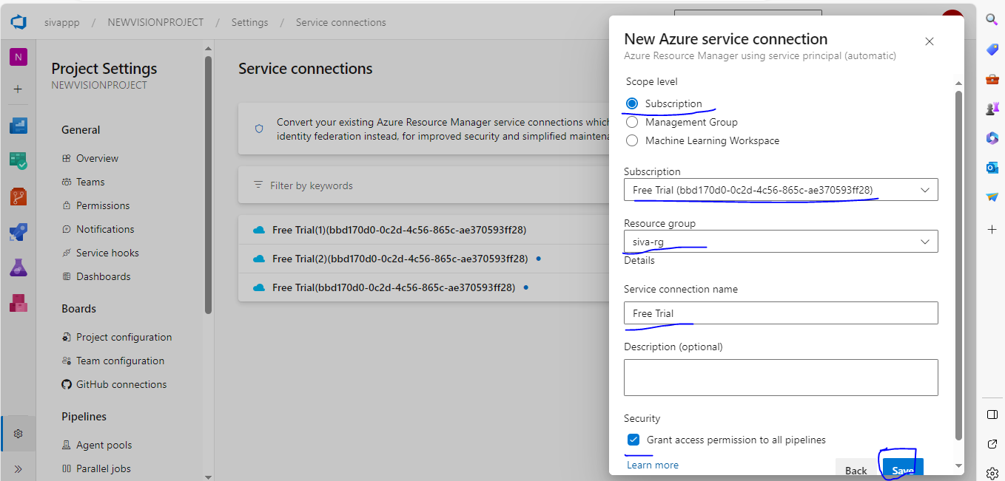

Windows vm add to azure devops in agent POOL:

First, we install PowerShell in windows agent system.
Then go to Project settings -> Pipeline->agentpool->click on add pool->

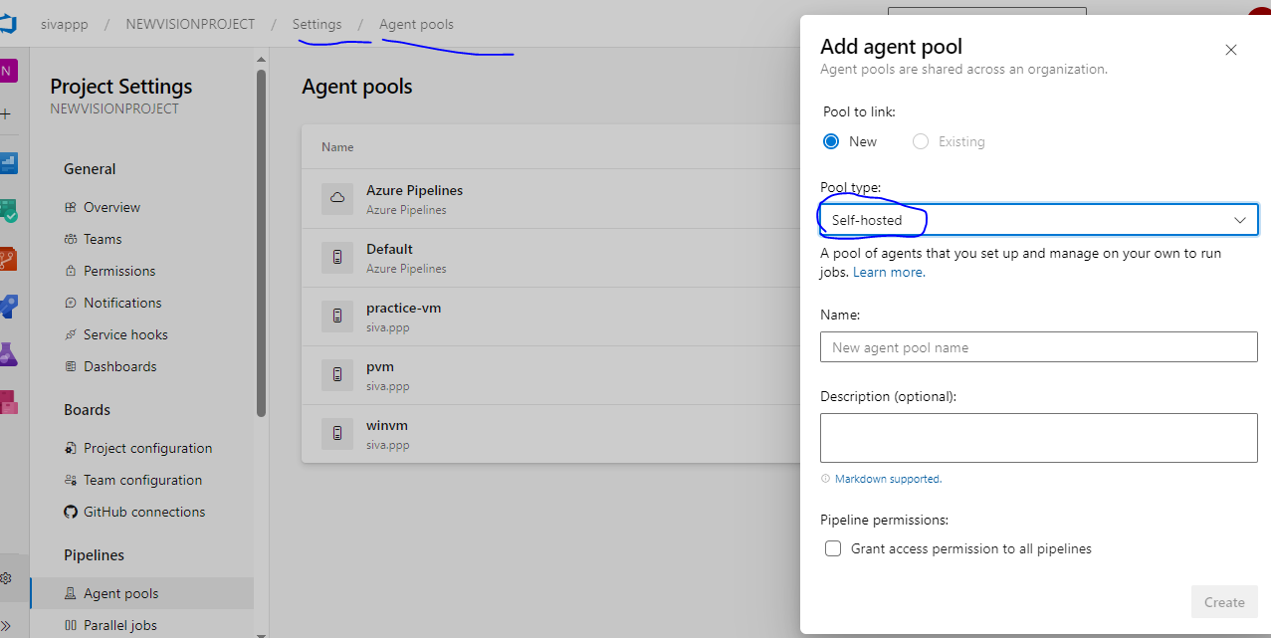

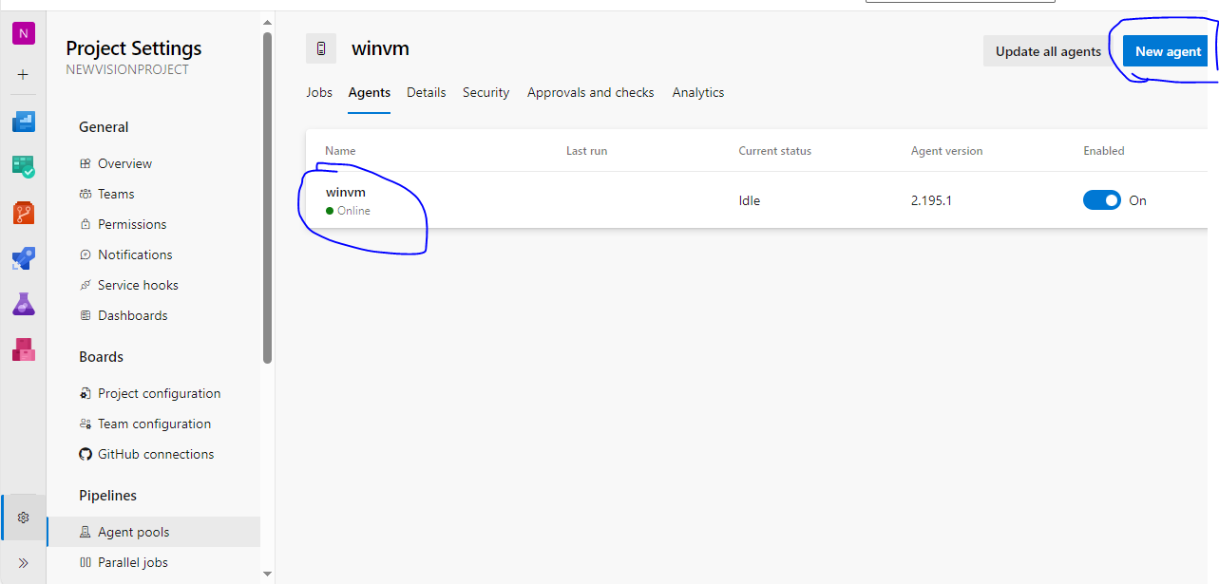

Click new agent -windows..
For add agent in pool find the below URL for commands.
How To Run Self-Hosted Azure DevOps Build/Release Agents – BMC Software | Blogs

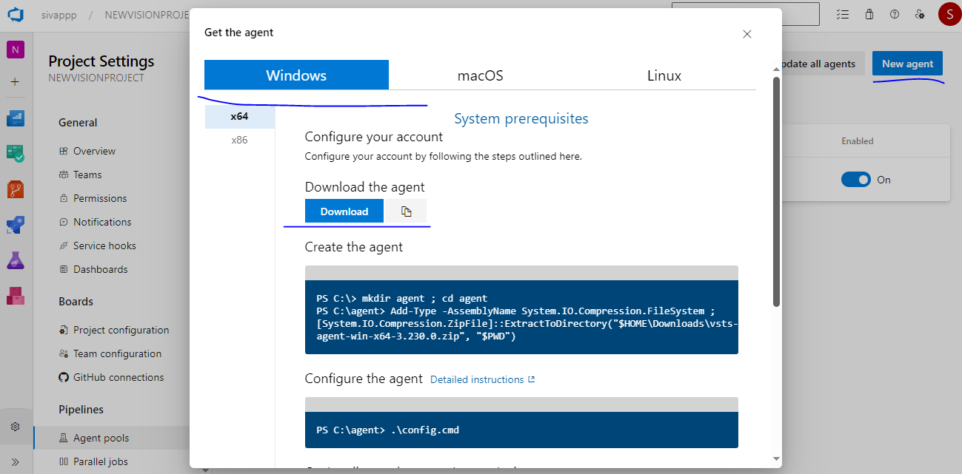

Once add vm to agent pool, then run pipeline.
For java project run pipeline build in selfhosted and then send war file to azure blob, for that we have install azure cli in build vm.
trigger:
- master
variables:
- group: "gameoflife" (this is vatiable group name)
pool: devserver (this is agent pool name)
stages:
- stage: Build
jobs:
- job:
steps:
- task: Maven@4
inputs:
mavenPomFile: 'pom.xml'
# mavenOptions: '-Xmx3072m'
goals: 'package'
# javaHomeOption: 'JDKVersion'
# jdkVersionOption: '1.8'
jdkArchitectureOption: 'x64'
publishJUnitResults: true
testResultsFiles: '**/TEST-*.xml'

- task: CopyFiles@2
displayName: 'copy files to build artifactory'
inputs:
SourceFolder: '$(system.defaultworkingdirectory)'
Contents: '**/target/*.war'
TargetFolder: '$(build.artifactstagingdirectory)'
- task: PublishBuildArtifacts@1
inputs:
pathToPublish: '$(Build.ArtifactStagingDirectory)'
artifactName: drop
- script: | # this war file copy to azure storage account
az storage blob upload --account-name warfilestore --account-key $(key) -f $(build.artifactstagingdirectory)/**/target/*.war --container-name $(cname) -n $(date +%F)-golife-$(Build.BuildId).war

